**Soueif, Ahdaf (23 March, 1950-)**

SUMMARY

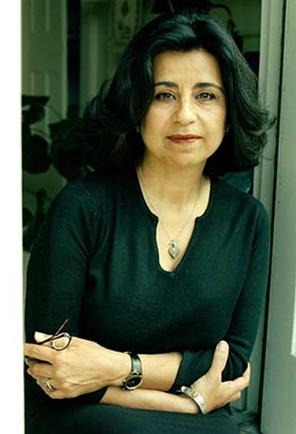Ahdaf Soueif is an Egyptian writer. She was born in Cairo in 1950 and, after completing her MA in her hometown at the American University, she went to England, where she obtained a Ph.D. in Linguistics from the University of Lancaster. She is the author of novels and essays, and she contributes to the diffusion of the literature written in Arabic by translating Arab authors. Her main characteristic is that, although writing her books in English, she uses the Arabic language as a narrative tool in her work. Besides her activity as a writer, she is also a journalist writing for both English and Arab newspapers and working in Arab and western television broadcasts. Soueif has an official website: [www.ahdafsoueif.com](http://www.ahdafsoueif.com) where she publishes information and material about her work and her activities in favour of human rights in Egypt.

http://publishingperspectives.com/2014/02/ahdaf-soueif-on-cairos-post-revolution-literary-scene/

MAIN ENTRY

Ahdaf Soueif is a writer who lives between two worlds: born and educated first in Cairo, she completed her studies in England and she lives now between two cities and two cultures: the English and the Arab. She writes in English and Arabic, each time trying to overcome the borders: of language first and consequently of culture. Reminiscent of the Chicana writer Gloria E. Anzaldúa’s statements about the use of different languages in *Borderland/La frontera*, Soueif’s strategy is a powerful tool to challenge the British presence in Egypt at the time of colonialism and the influence the English language has in the global context of today. Interwaving Arabic into English, Soueif shows how one’s mother tongue can adapt to the surrounding linguistic environment.

Writing in English, Soueif allows Arabic to emerge in her narrative, especially when dealing with historical issues, constantly reassessing the Arab Egyptian national identity and resisting the linguistic colonialism of English.

In her essay collection *Mezzaterra* (2004) Soueif tells the reader about what it means to live between two worlds and why she alternates between fiction writing and journalism. In her opinion, fiction cannot be forced and is not suitable to deal with today’s concerns while journalism is more apt to present and discuss them. When she came to England following her English husband in the Mid-Eighties, Soueif noticed that covering the Arab world was necessary because “it was impossible to find in the media of the West a coherent interpretation” (5). She, therefore, decided to write for newspapers and to participate in radio and television broadcasts to present the Arab world in a different way. The concern with the representation of the other (both ways) is a central feature of Soueif’s writing. After publishing two short story collections - *Aisha* (1992) and *Sandpiper* (1996) – she achieved high visibility with her novel *The Map of Love* (1999), which tells the love story between Lady Anna Winterbourne, an upper-class Englishwoman, and Sharif, an Egyptian nationalist in parallel with the love story between Isabel – Anna’s great granddaughter – and Omar. Through the accidental discovery of Anna’s notebooks, *The Map of Love* gives an account of important issues in the history of the relation between Egypt and Great Britain, and supports the possibility of a cultural encounter, as represented by the bond between Anna and Sharif in the past and Isabel and Omar in the present. The novel was shortlisted in 1999 for the Man Booker Prize, has been translated into twenty-one languages, and sold over a million copies.

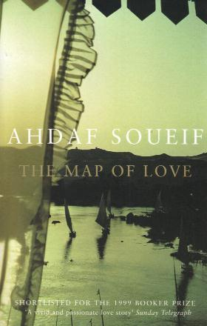

*The Map of Love*, cover.

Soueif’s most recent publication is *Cairo, My City Our Revolution* (2012) reprinted in 2014 with the title *Cairo: Memoir of a City Transformed*. In this book – halfway between a journal and an essay - Soueif tells the reader her experience during the 18-day Egyptian Revolution in 2011, when she was in Cairo to follow the events for *The Guardian*, and later on, when she returned to England. In the book, Soueif merges personal experience and feelings regarding her sons and friends who participate in the Revolution with political commentary. In the 2014 edition, the author presents an up-to-date version of the text.

Video: Ahdaf Soueif on art and politics after the Egyptian Revolution at the Perth Writers Festival (Australia), 2013

<http://blip.tv/slowtv/ahdaf-soueif-on-art-and-politics-6546300>

**List of works**

Novels

*In the Eye of the Sun* (1992) London: Bloomsbury.

*The Map of Love* (1999) London: Bloomsbury.

Short stories

*Aisha* (1983) London: Jonathan Cape.

*Sandpiper* (1996) London: Bloomsbury.

*I Think of You* (2007)*.* New York: Anchor Books.

Essays

*Mezzaterra: Fragments from the Common Ground* (2004)New York: Anchor

Books.

*Cairo. My city, our revolution* (2012) London: Bloomsbury.

*Cairo: Memoir of a City transformed* (2014) London: Bloomsbury and New York: Knopf.

As editor

*Reflections on Islamic Art* (2012) Doha: Bloomsbury Qatar Foundation Publishing.

Site:

[www.ahdafsoueif.com](http://www.ahdafsoueif.com)

**Further reading**

M. Albakry and Patsy Hunter Hancock (2008) ‘Code switching in Ahdaf Soueif’s The Map of Love’, *Language and Literature* 17: 221-234.

El-Feky,M. (2012) ‘Discovering the Self and the Other: narrative in Ahdaf Soueif’s *The Map of Love’,* *International Review of Social Sciences and Humanities* 3 (1): 141-169.

Moore, Linsday (2008) ‘Ahdaf Soueif, *The Map of Love*’. In Ead. *Arab, Muslim, Women. Vice and Vision in Postcolonial Literature and Film*. London and New York: Routledge, 146-158.